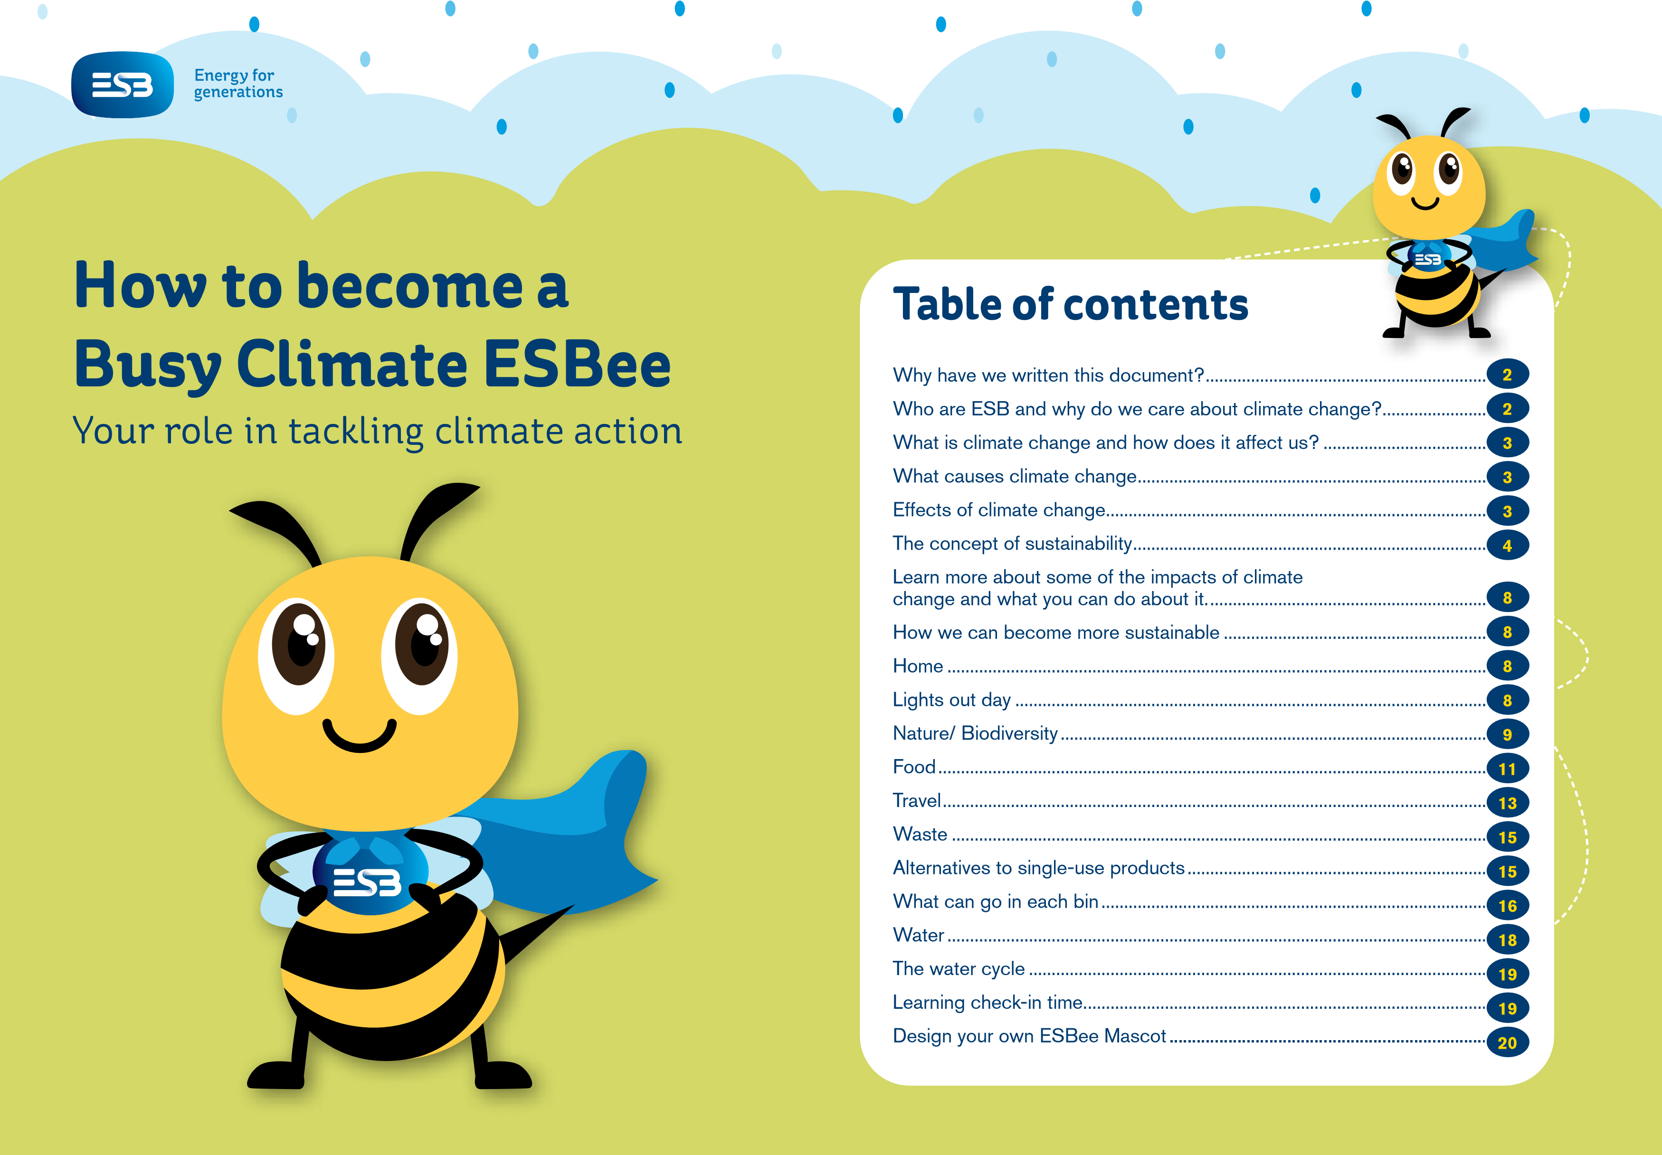
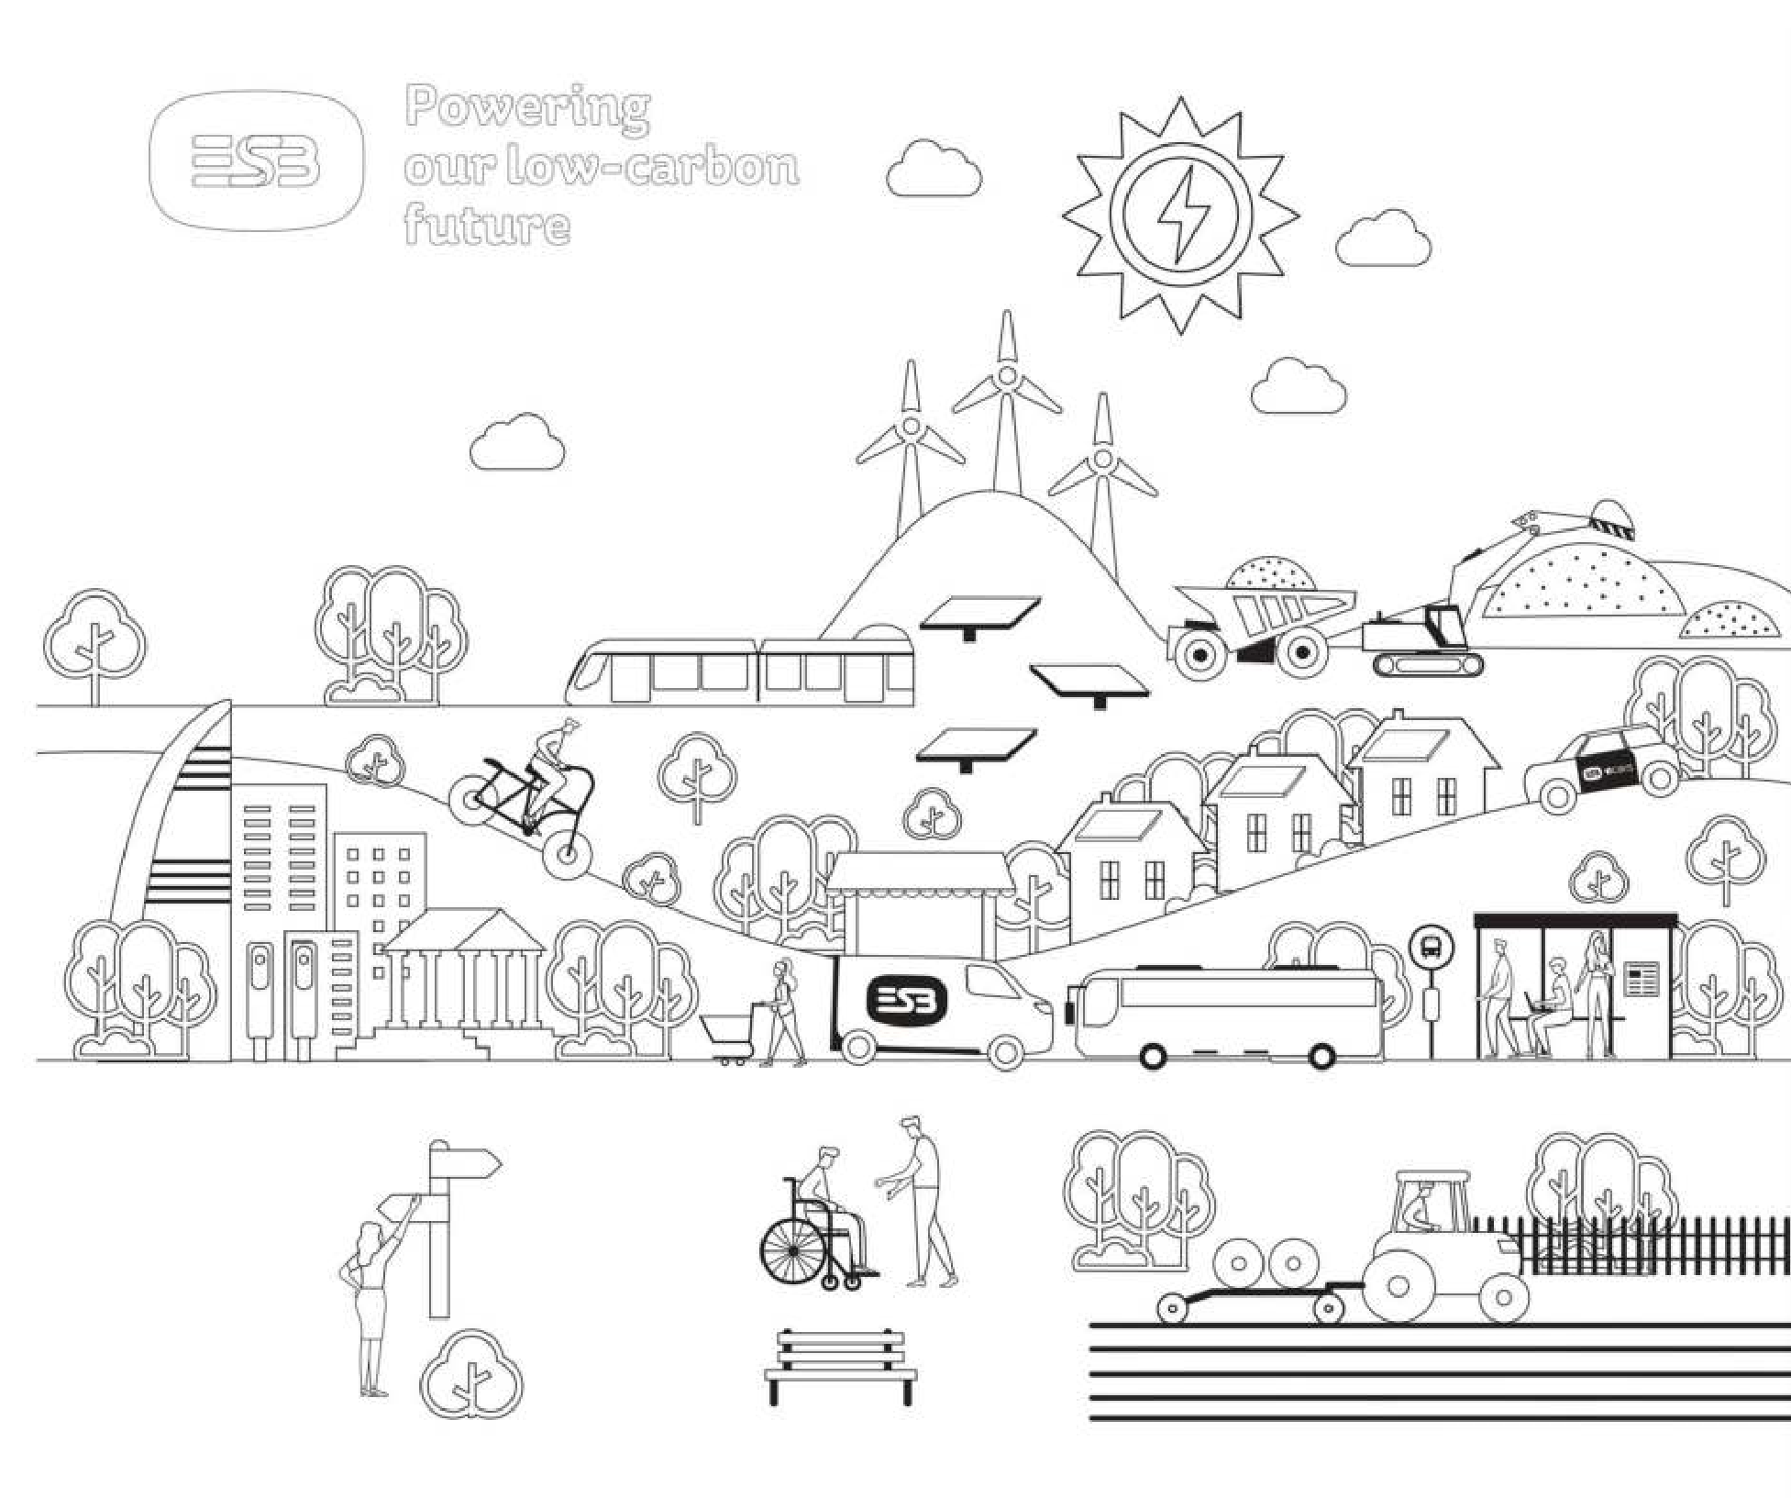
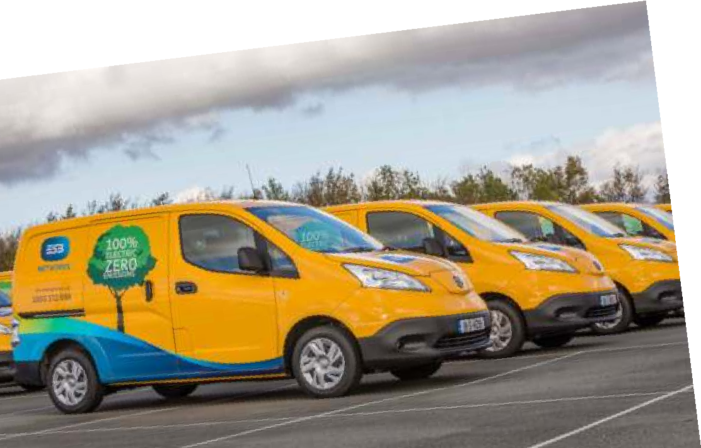

Why have we w
r
itten
th
is document?
Climate change is affecting every person

and every other species (both plants and animals)
on this planet, climate change is occurring

because of human activity
. We are also the best

placed to do something about it. We can all

play a part and help convince those around us,
friends, and family to act too.
Grab your pencils and crayons and colour in this
ESB colouring page!
Activity 1
Who are ESB and wh
y do we
care about c
limate change?
W
e are Ireland’s national electricity utility
,
part of Ireland’s history since 1927, we have
been heavily involved in Ireland’s development

through the introduction of electricity to homes,
schools & businesses. W
e believe that clean
renewable electricity is the best option we have,
to help tackle climate change.
W
e live and work
in every community around Ireland, so this is

a big deal for all of us.
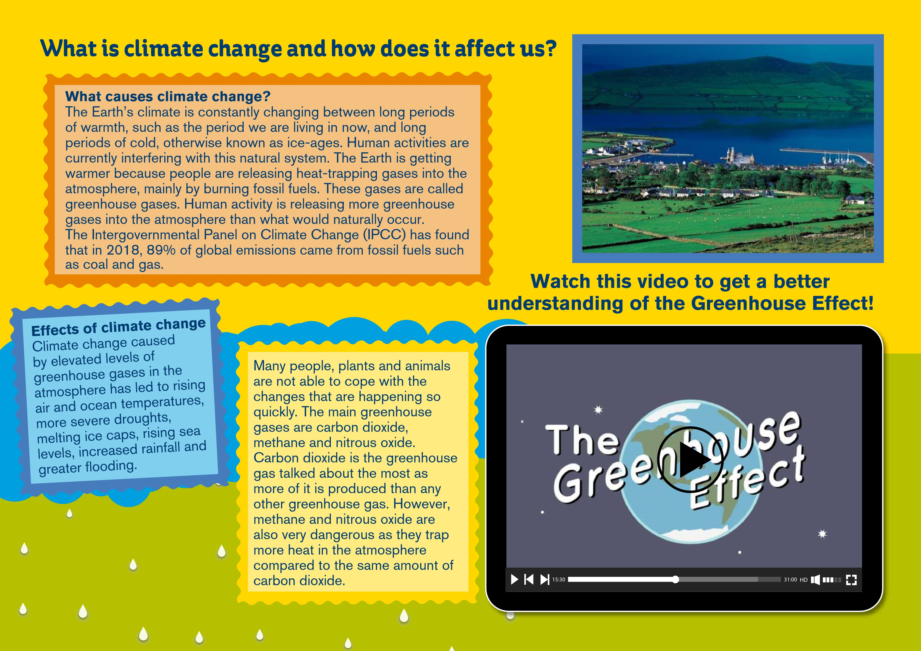
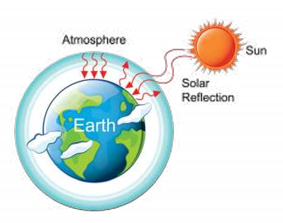
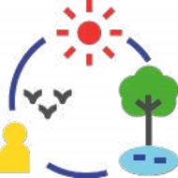
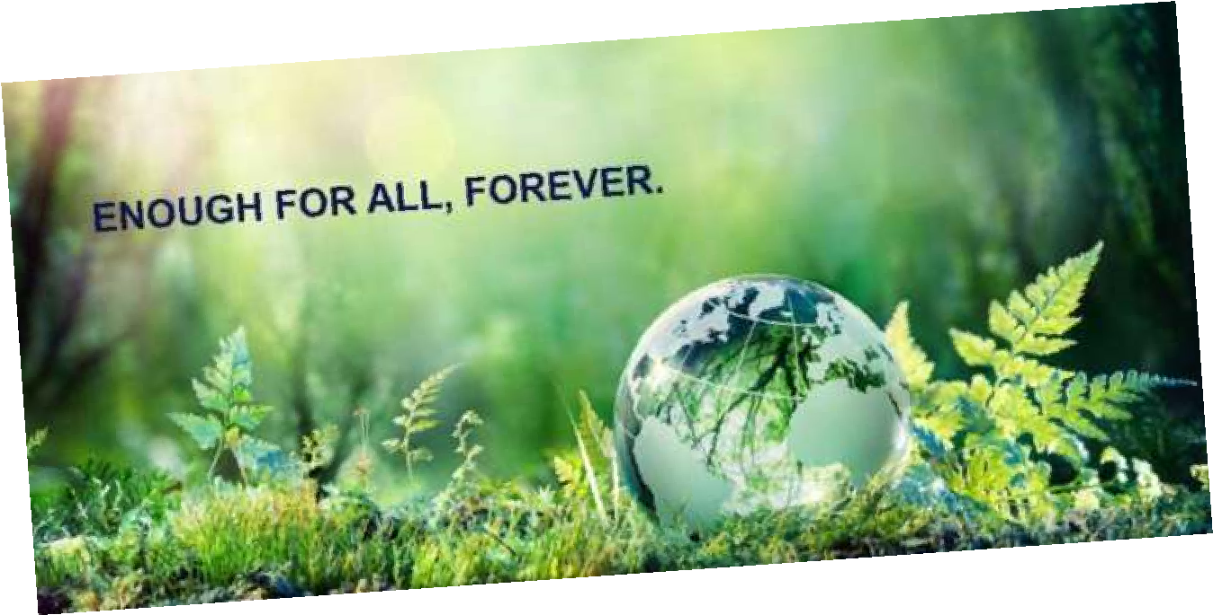

How to become a Busy Climate ESBee |
4
Table of contents

The concept of sustainability
Sustainability means enough for all, forever. All life on earth
depends on the environment. The natural resources that
come from the environment include food, water, plants,
and minerals. Sustainability is the idea that humans must
interact with the environment in a way that ensures there
will be enough resources left for future generations of all
humans, animals and plants.
Learn some sustainability
themed key words!
Activity 2
The greenhouse effect
This is a process which occurs
when gases in Earth’s atmosphere
trap the sun’s heat. This makes
sure that Earth is a habitable
place to live as it warms Earth’s
surface and the air above it.
Ecosystem
An ecosystem is a community of
organisms and their environment, including
non-living things. Ecosystems can be as
small as your garden, or as large as the
ocean, and all organisms have specific
vital needs such as food, water and air in
order to survive in an ecosystem.
Carbon footprint
Your carbon footprint is the amount
of carbon dioxide released into the air
because of your own energy usage,
such as transportation, electricity and
food. Your choices make a difference
– so turn off the lights and the TV to
reduce your carbon footprint!
Atmosphere
Solar
Reflection
Sun

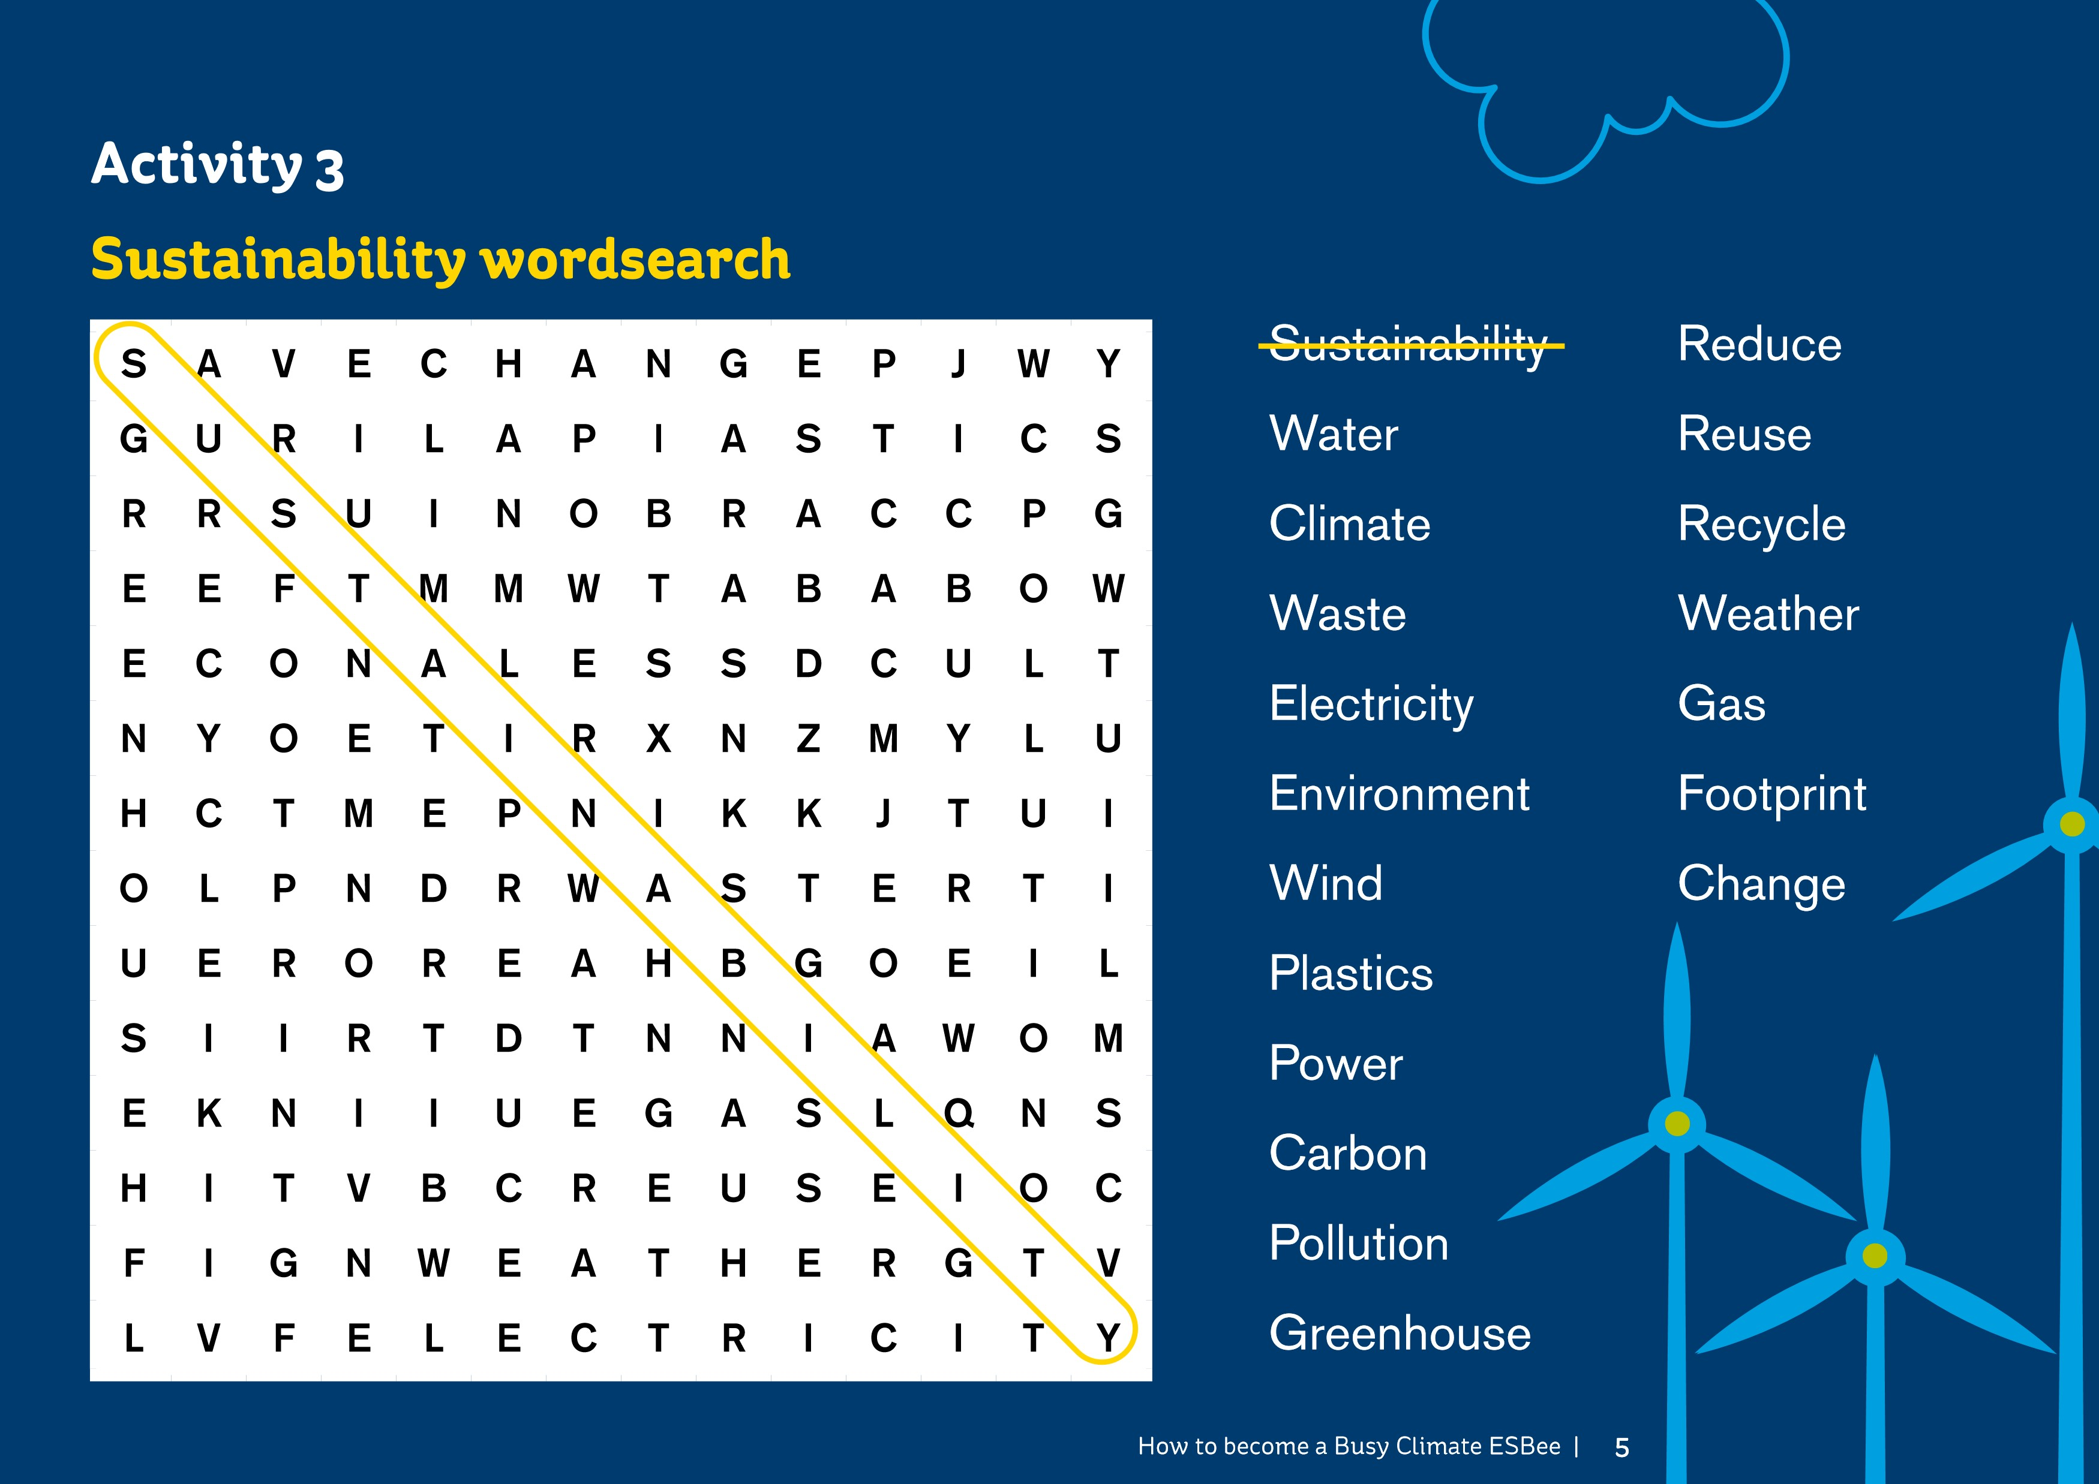
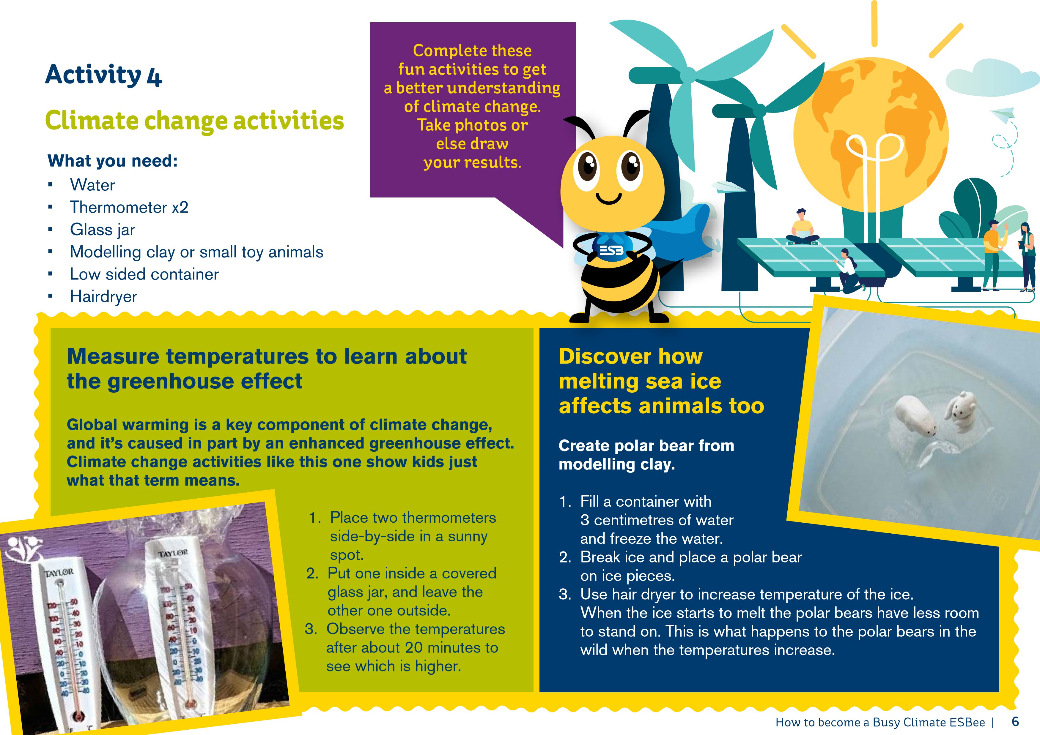
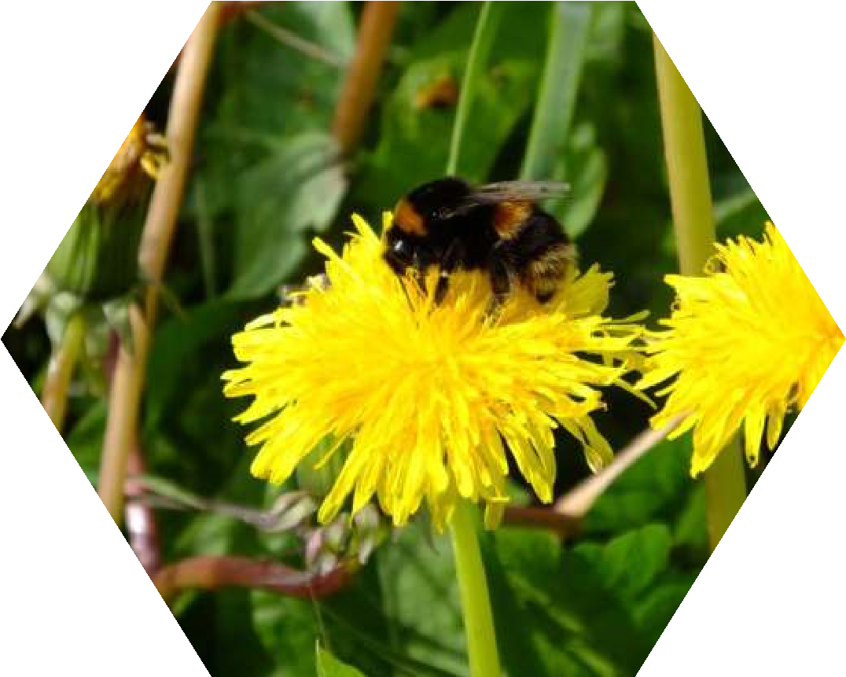


How to become a Busy Climate ESBee |
7

Home
Nature
Travel
Food
Waste
Water

Learn more about some of the impacts of climate change and what you
can do about it
How can we be more sustainable at home?
Home
Activity 5
Movie time
Watch
“The Lorax”
on
Netflix or read the book to
show how nature affects
the home.
Activity 6
Lights Out Day
Ask parents or teachers to
organise a day to not use lights
inside the house or classroom
to save energy and see how
much we rely on energy.
How is it impacting / impacted by climate change?
Humans burn fossil fuels to power cars and other machines, to generate
electricity, and to keep buildings warm. Waste gases are released, including
carbon dioxide. As the human population increases, more fuel is used, and more
carbon dioxide is released. Many of us overconsume the goods we use. Such as
clothes, food, water and technology. This means we buy/use more than what we
need. During the production of these items’ greenhouse gases are released. Many
end up in landfill having never been used.
What can you do?
Insulating our homes helps to keep
our houses warm in the winter and
cooler in the summer. T
urning off
the lights when we don’t need them
saves electricity
. Buy fewer products
and make sure the products you buy
minimise the impacts of climate change.
Learn how to mend holes in clothes
instead of buying new ones. Get a
reusable water bottle instead of using
plastic bottles. If you spend a lot of
money at home to keep your house
warm, talk to your parents or
guardians about installing a heat
pump as a better alternative to using
gas or oil to heat your house.
What is it?
The home is where we live and the
communities which surround our everyday
lives. The home is our everyday lives.
All topics in this workbook tie into
the home.
We travel from the home,
waste, food and water is at home, nature
is all around us at home. Most houses
in Ireland are heated by gas or oil and
have petrol or diesel cars. Electricity in
our houses can either be created through
fossil fuels or renewable energy such as
wind, solar, and ocean energ
y.
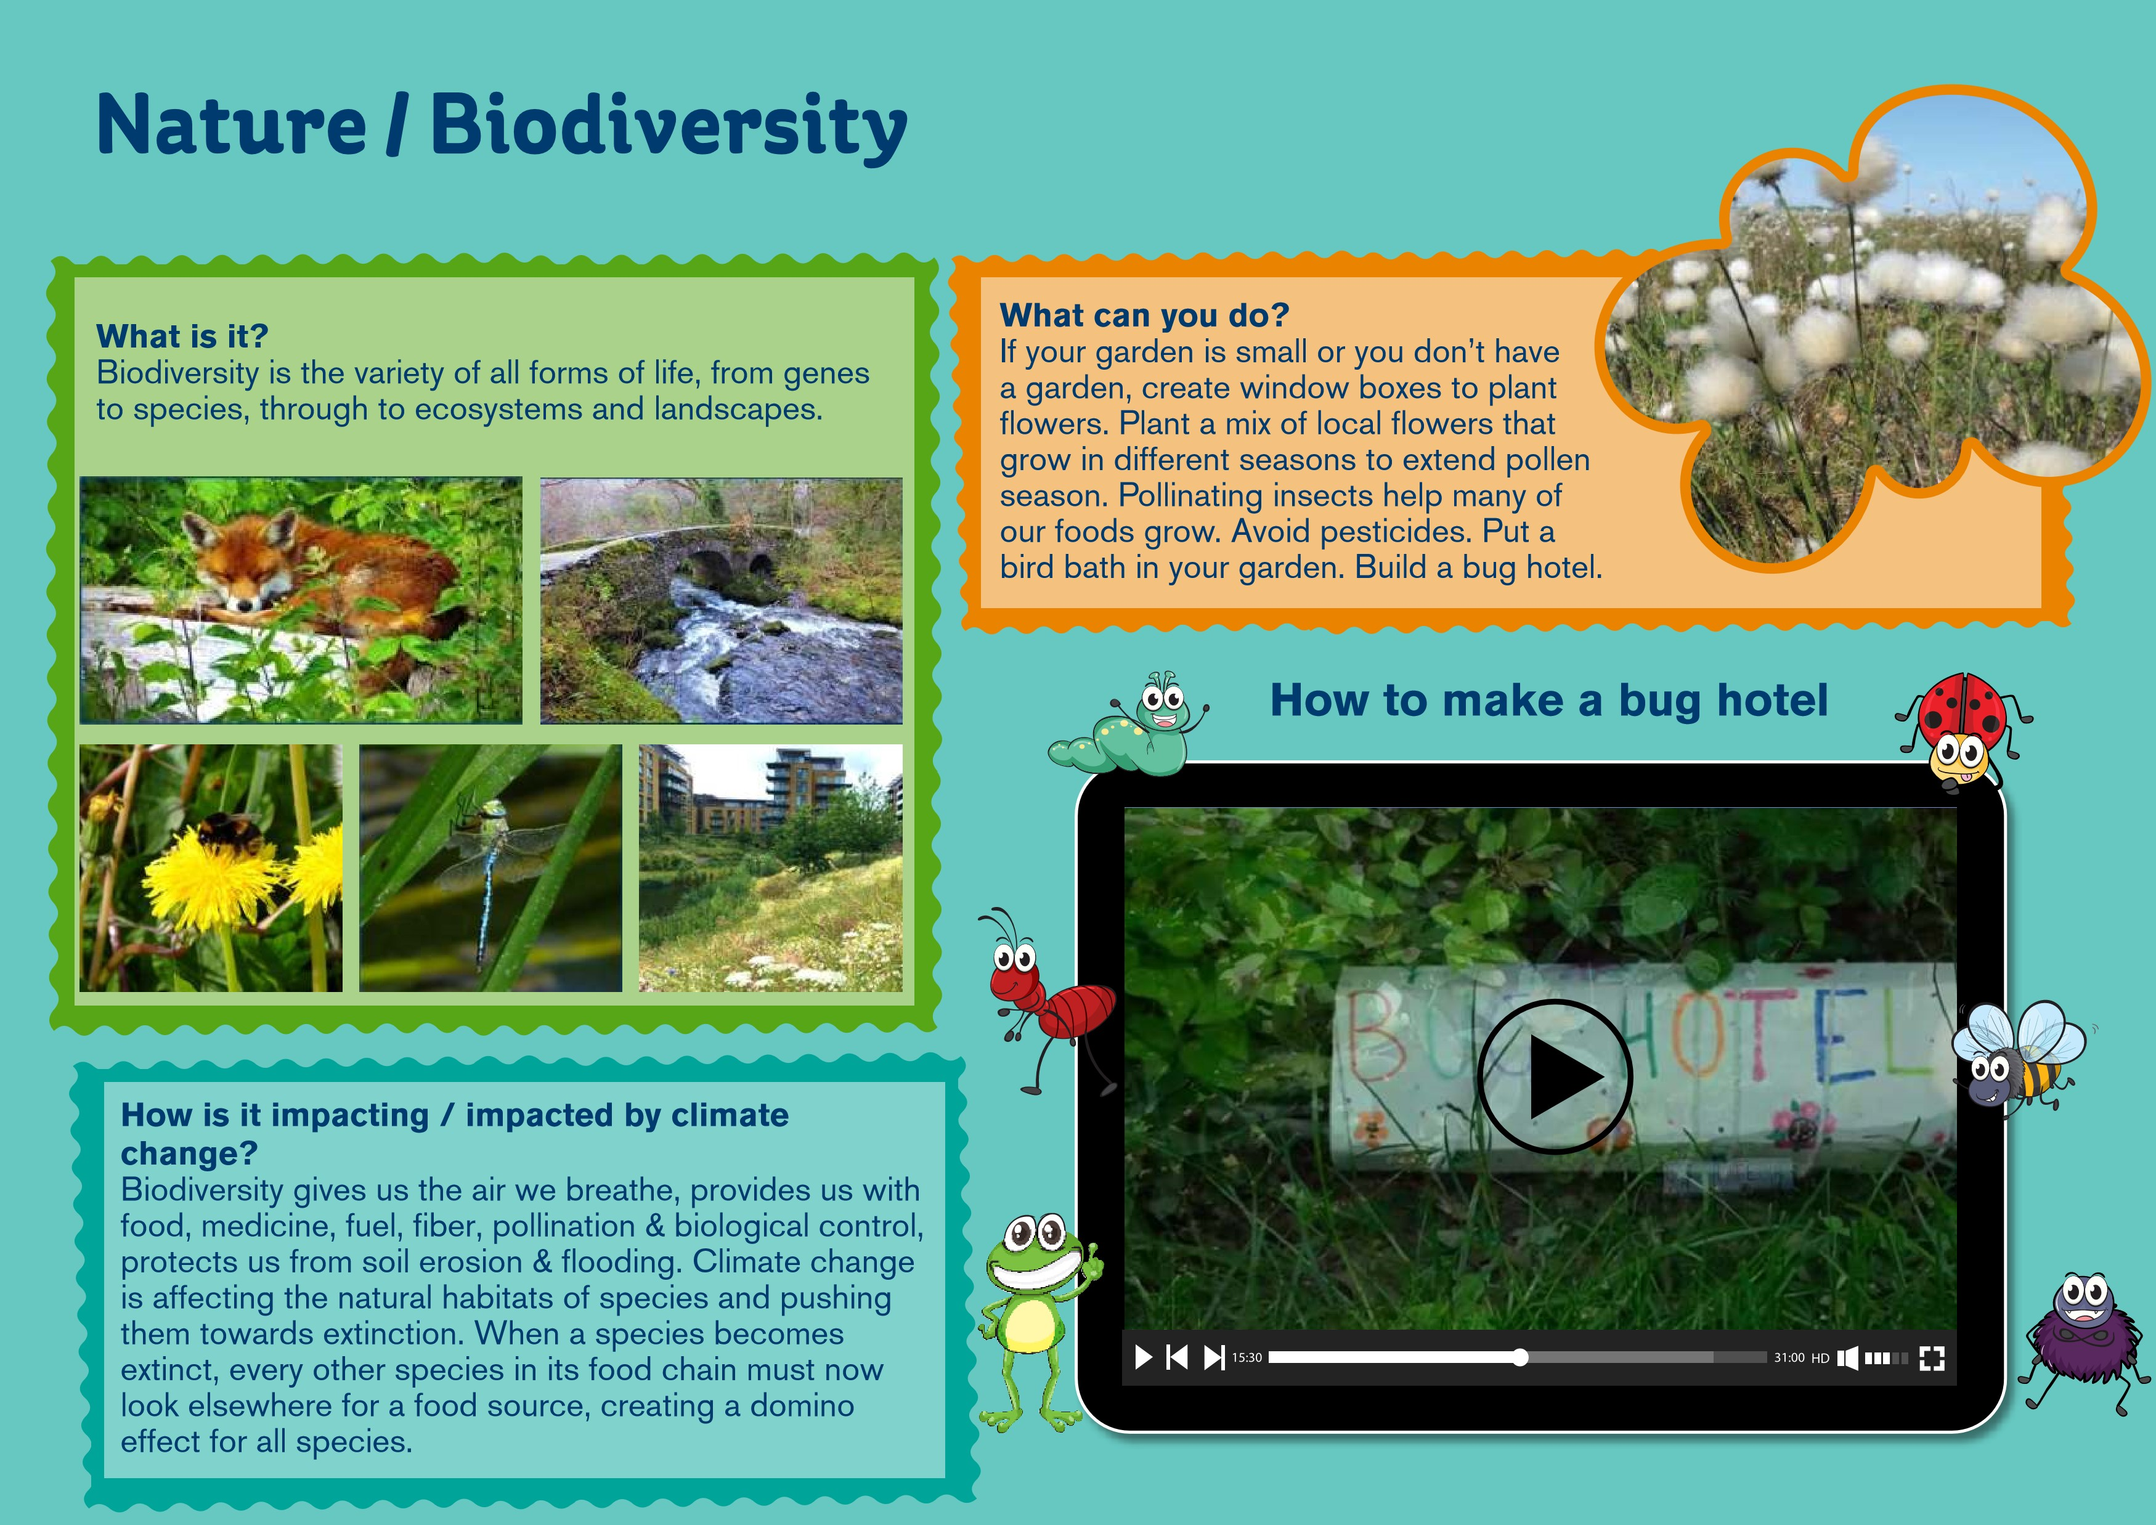
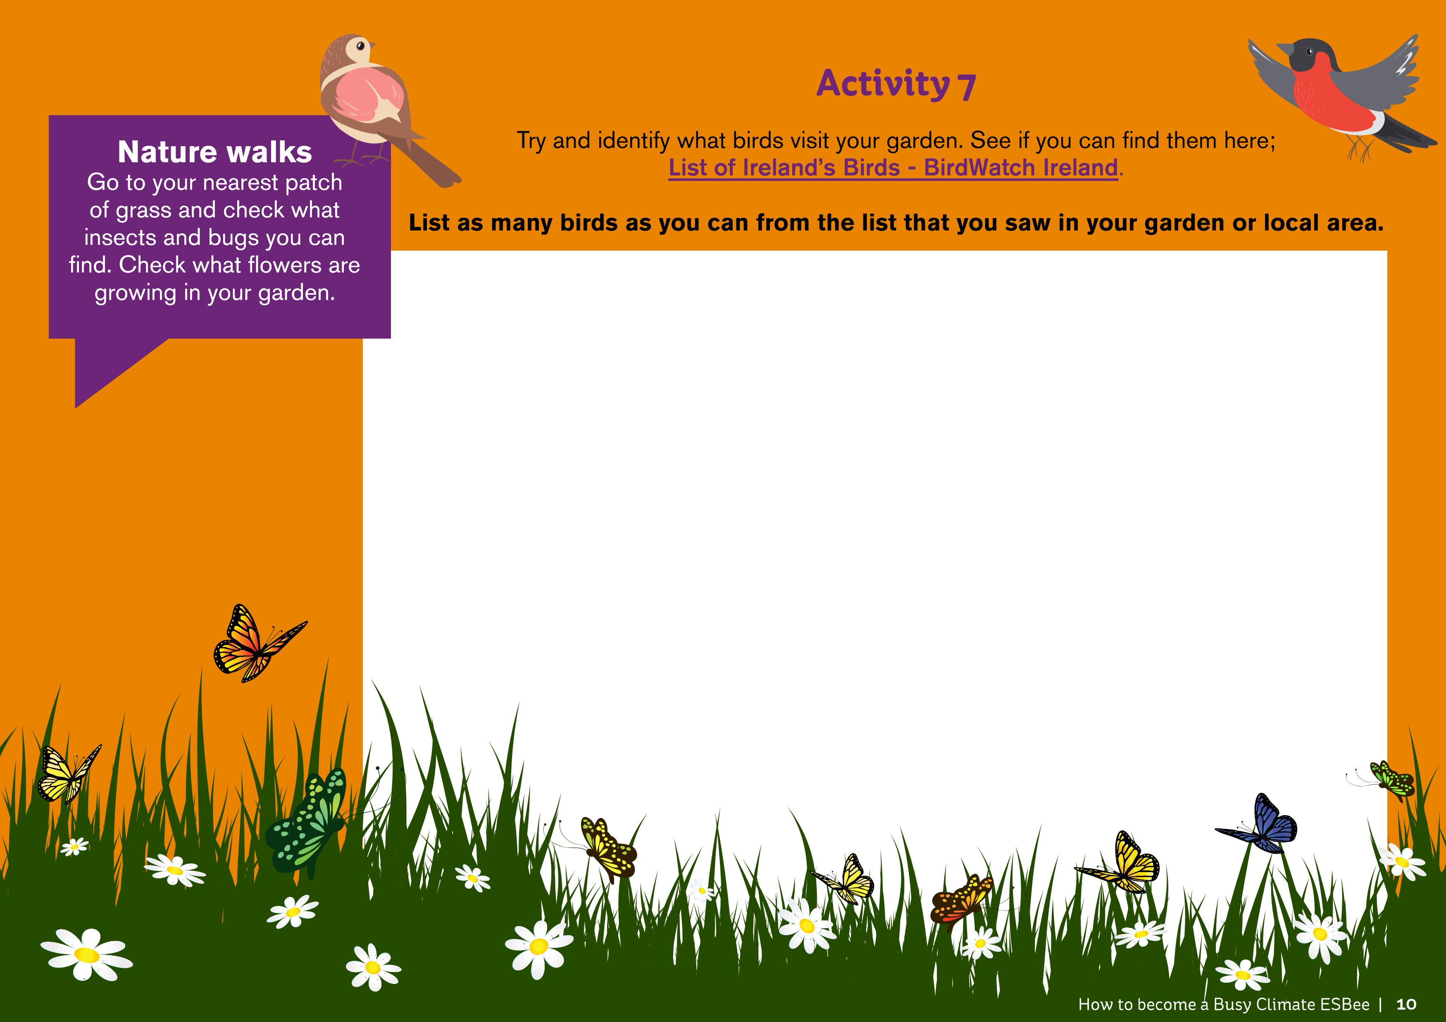

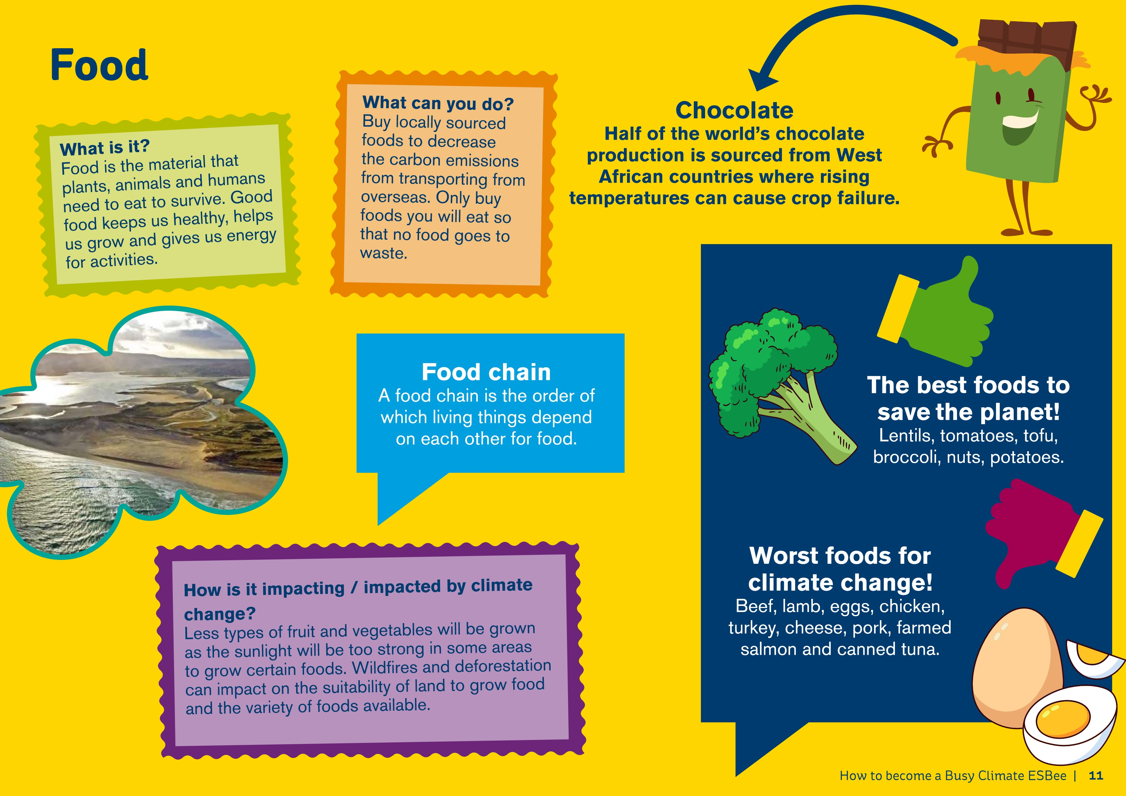
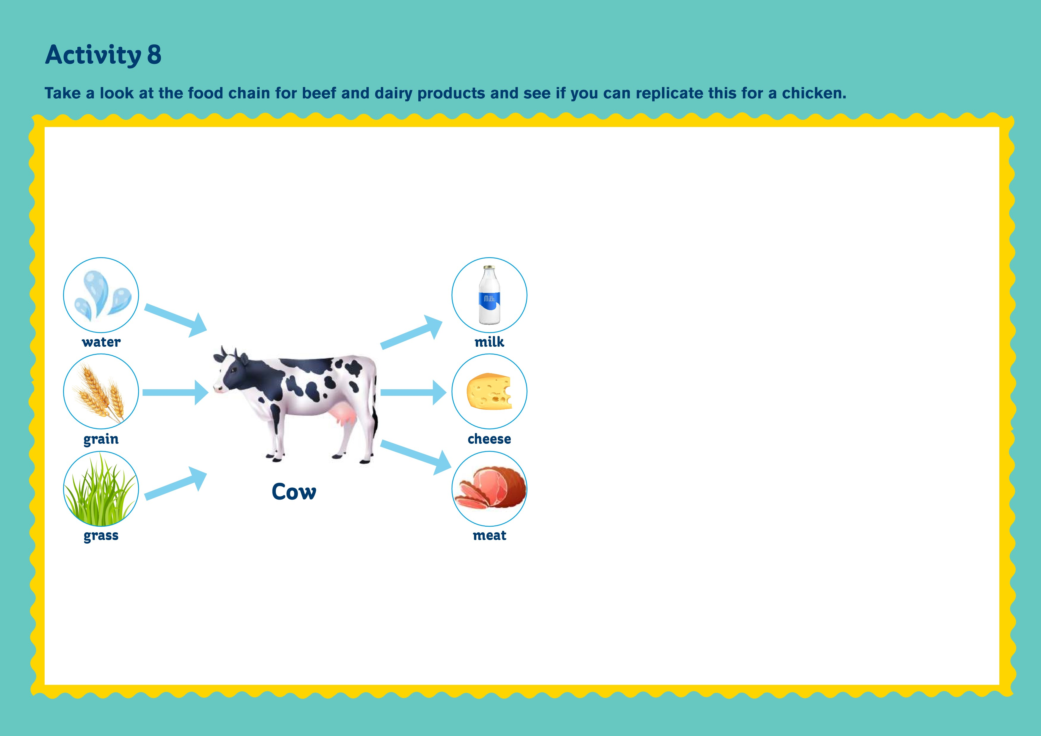




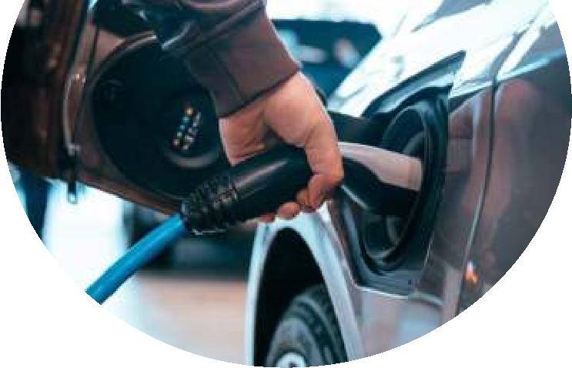
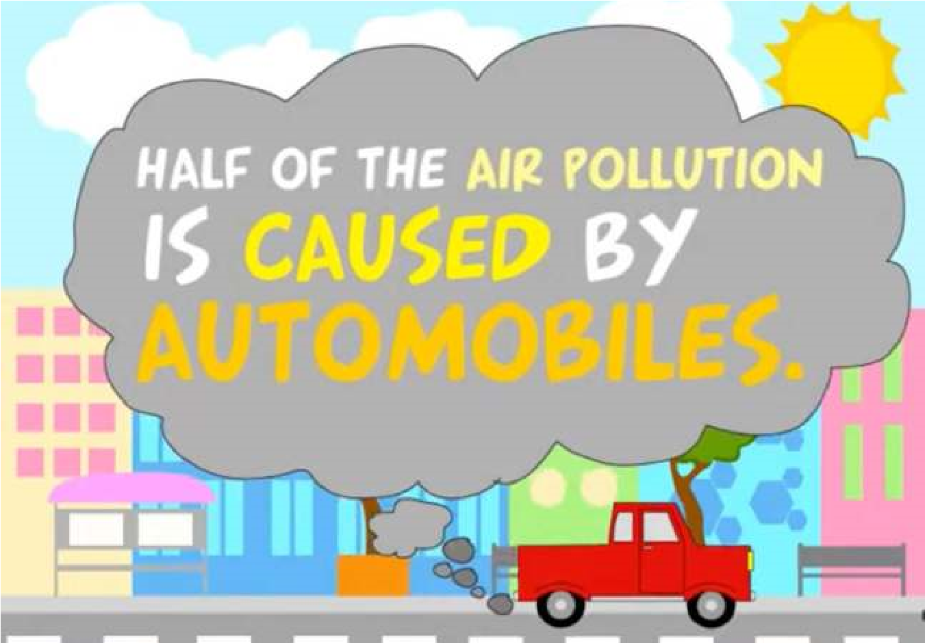

How to become a Busy Climate ESBee |
13
Table of contents
Travel
What is it?
Travel is the journey to get from
one place to another. You travel
to school and maybe to Spain on
your summer holidays. Some of
your food must travel by plane,
ship or truck to get to the shop
you buy it in for it to end up in
your lunch box. There are many
forms of transport such as boat,
plane, car, bike and bus.
How is it impacting / impacted by climate change?
Most cars in Ireland are petrol or diesel. In 2021, heat
and transport made up 40% of Ireland’s carbon dioxide
emissions. Production of cars and other vehicles release
greenhouse gases from the factor
y
. Extracting fossil fuels
to run our vehicles can damage local ecosystems as oil
spills can happen when transporting oil by ship or through
pipelines. These gases also make air quality worse to breathe.
What can you do?
W
alking and cycling more is not
only better for the environment
but it is also good for our health.
Use public transport
Cycle
Scoot
Carpool
Electric car
13

How to become a Busy Climate ESBee |

How does car pollution affect the
o
environment vide
Electric cars
Electric cars are cars that
can be plugged in and
charged using electricity
with no need to use
petrol or diesel. They are
cheaper to run and much
better for the environment
and air quality. The more
electricity that comes
from wind and solar (sun),
the cleaner the electricity
becomes.
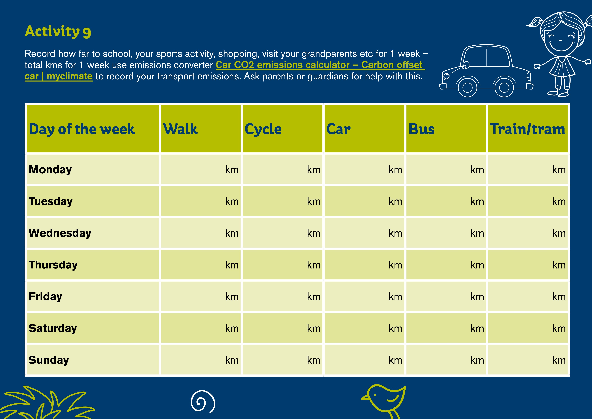

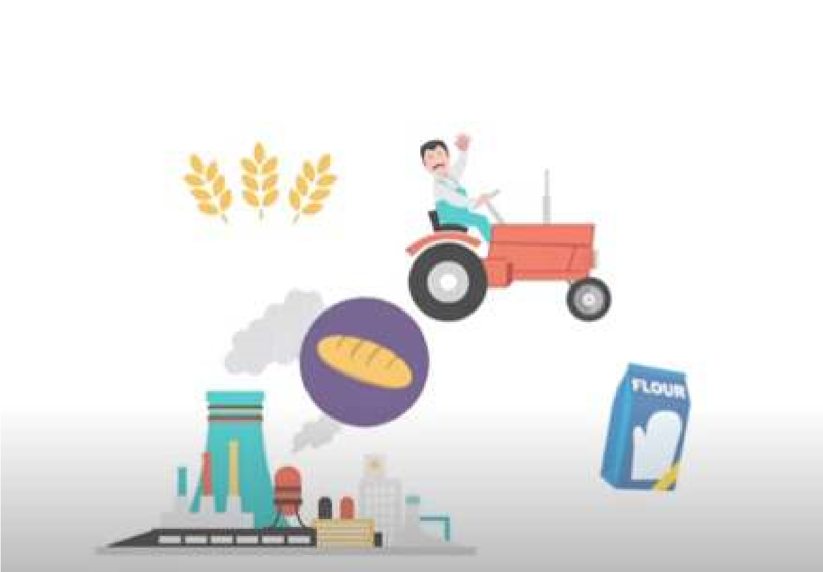
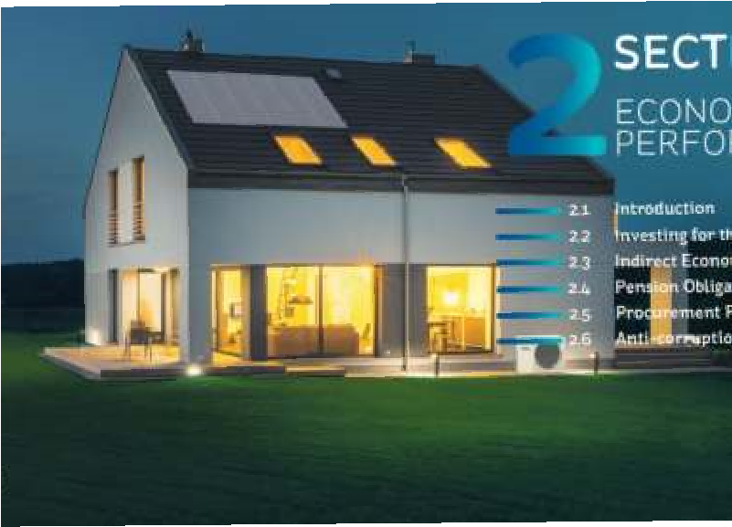

Waste
What can you do?
Reduce reuse recycle repurpose
Reducing is the most important step in this process. Refuse
to buy unneeded items. Buy items of better quality that
last longer so you do not need to replace it as often. Buy
clothes and furniture from second-hand stores and give away
unwanted items instead of dumping them. Think of new uses
for items you don’t need any more. Ask people what present
they want for Christmas instead of buying something they will
not use. Buy items with less packaging that uses cardboard
instead of plastic.
o
Food waste vide
How is it impacting / impacted by
climate change?
Plastic waste produces greenhouses
gases at every stage of its lifecycle.
Waste
management such as transportation and
incineration are a huge contributor to the
production of greenhouse gases.
What is it?
Waste is something we
throw away or get rid of that
we don’t use. An example
of waste could be plastic
wrappers and out of date
food.
Alternatives to
single-use products
Plastic bottles
– Reusable bottle
Straws
– Metal, bamboo and paper straws
Cling-film
– Lunchboxes
Balloons
– Try some other activity to
celebrate such as flying kites, planting a tree
or decorating with bunting, flags or streamers
Plastic book covers
- Wrapping paper
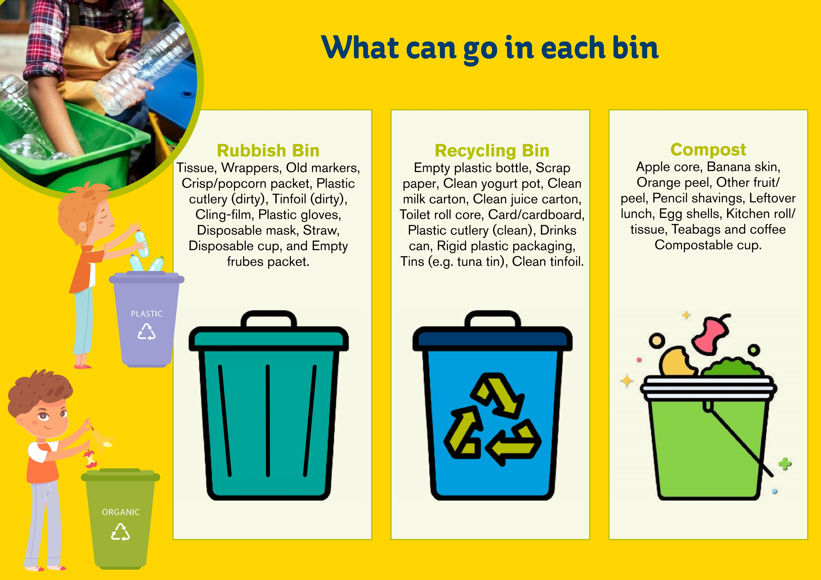
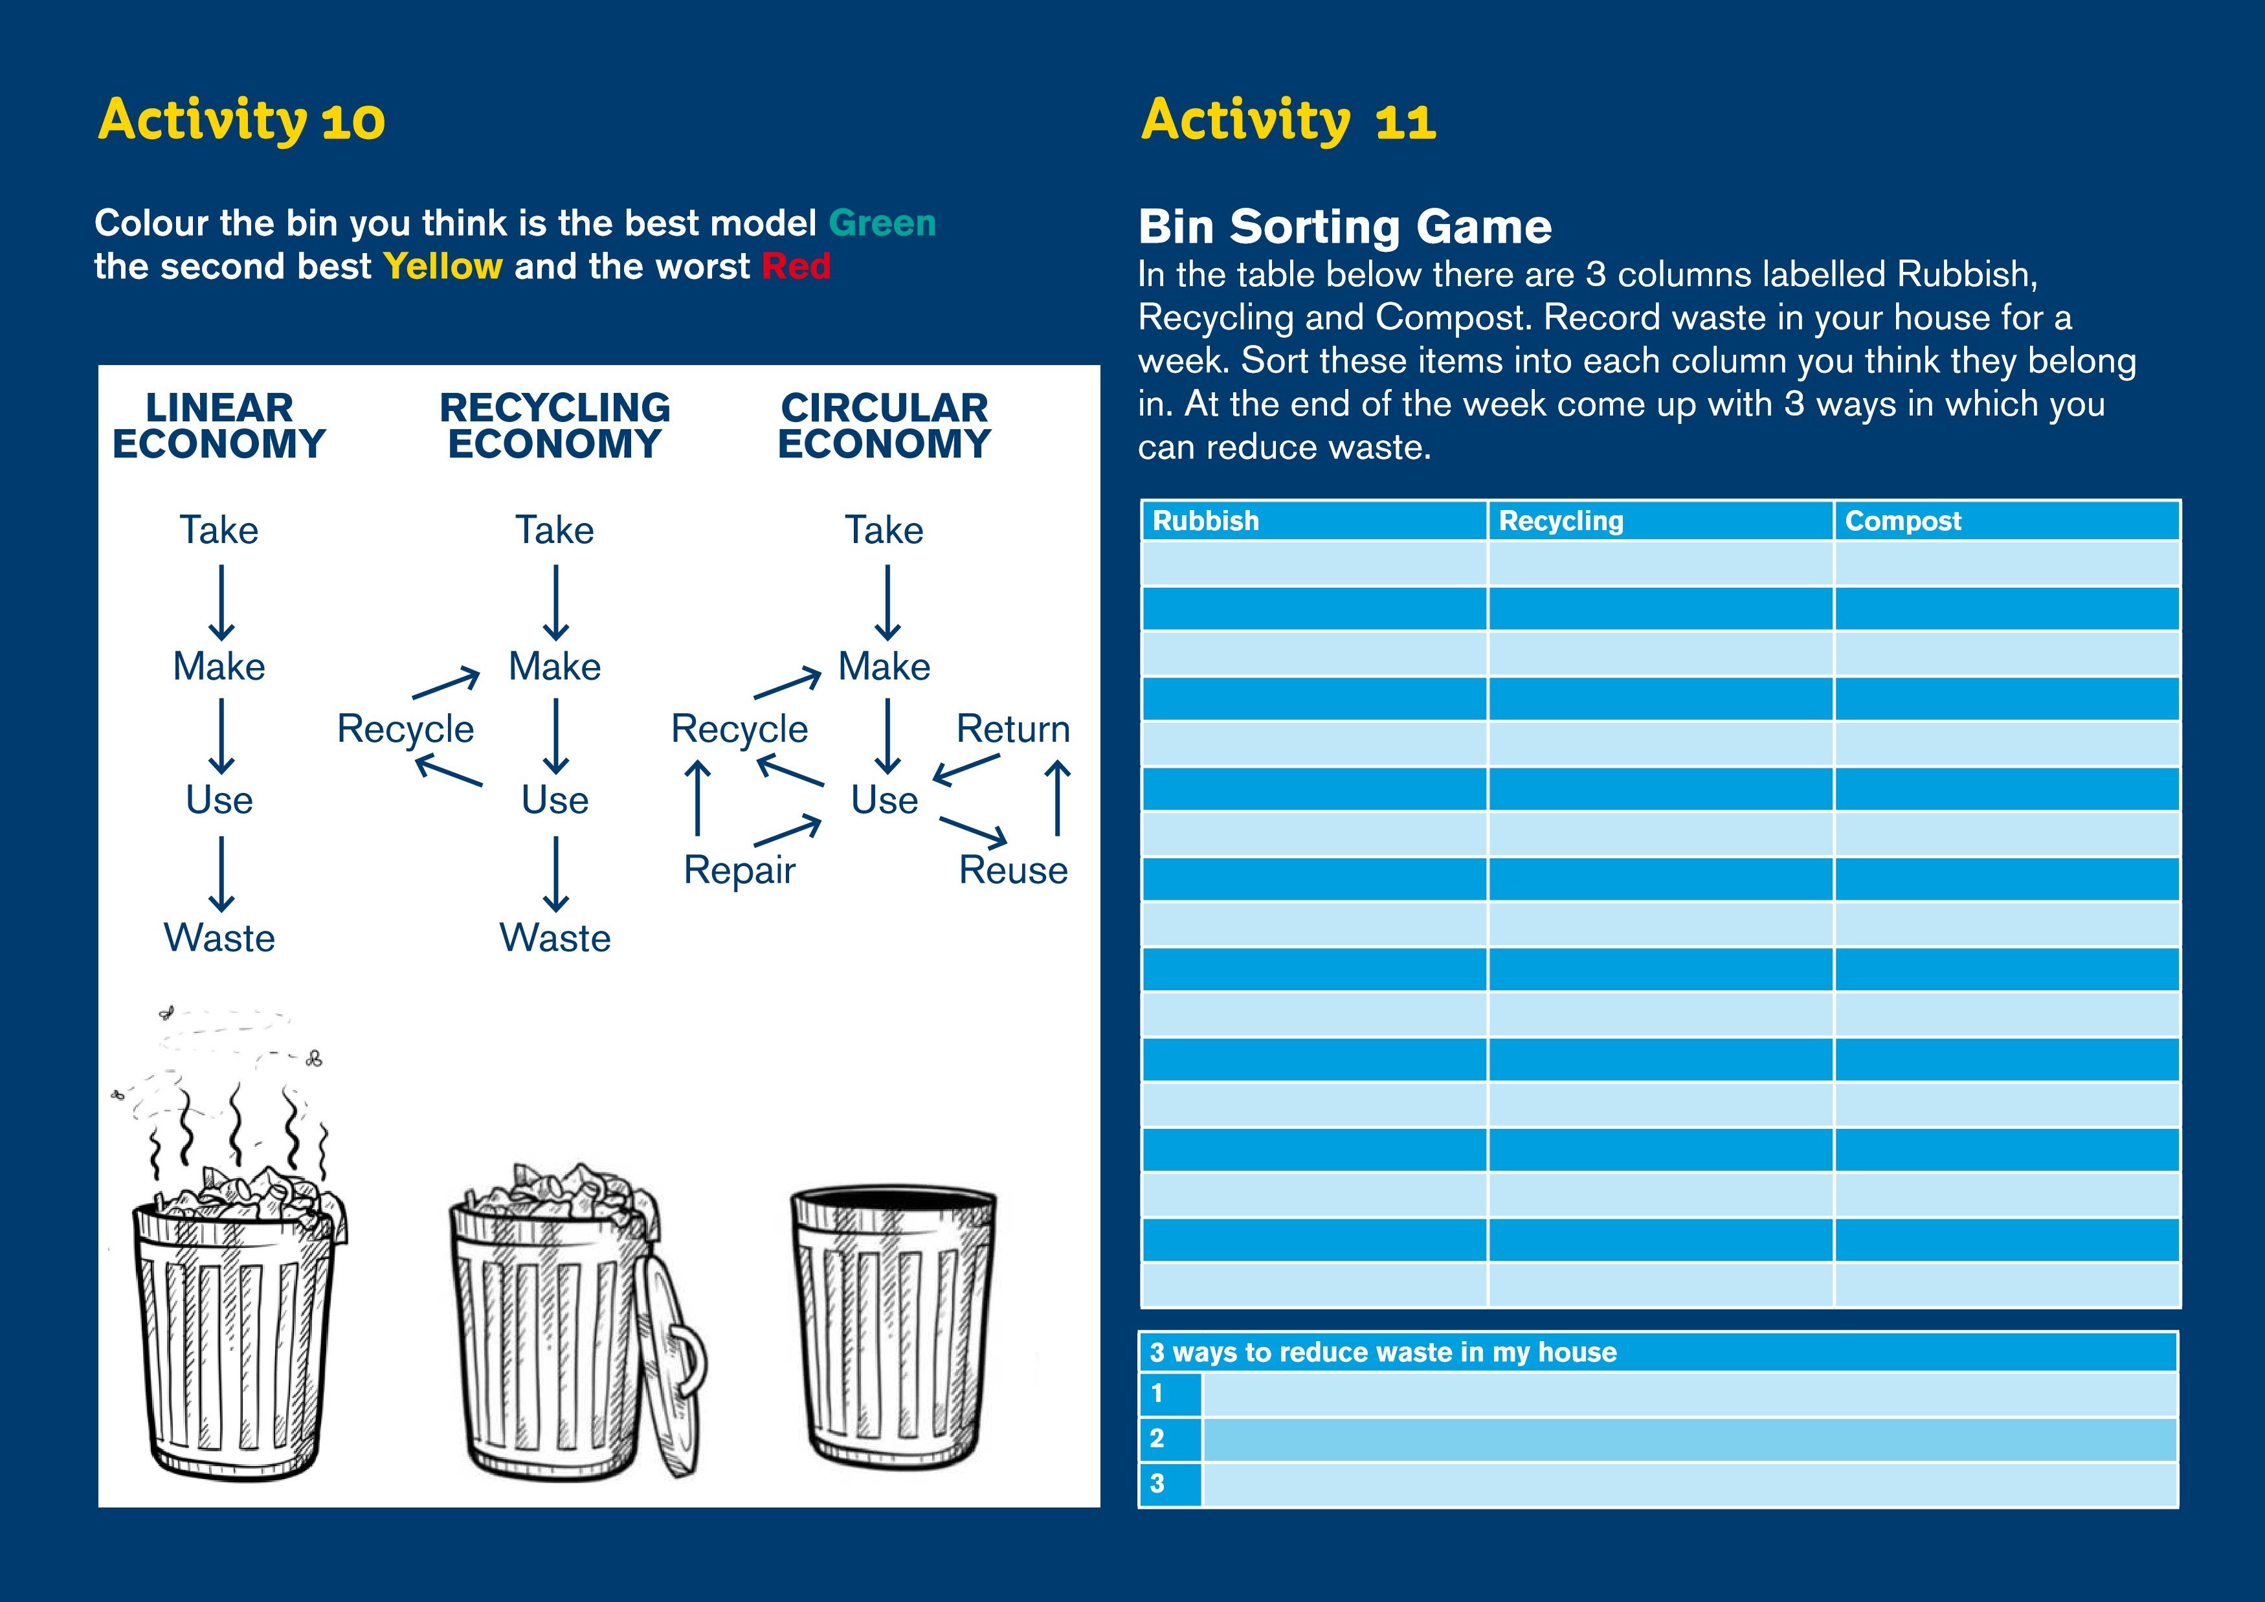
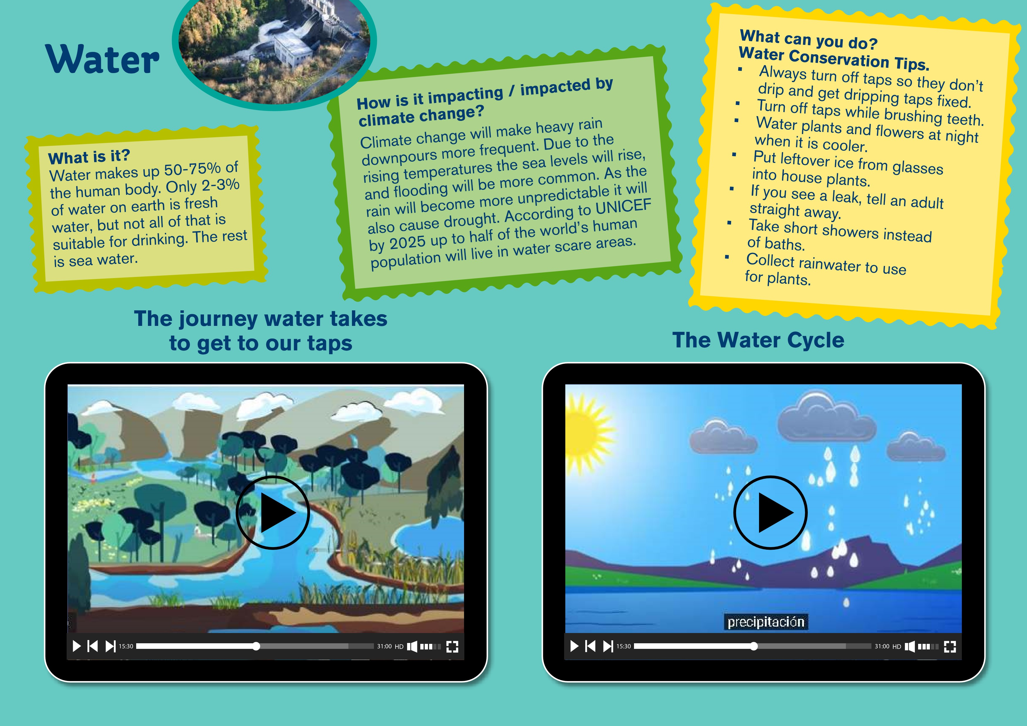
How to become a Busy Climate ESBee |

19
Table of contents

Activity 12
Draw The Water Cycle
Learning check-in time. If you have paid really
close attention, you should be able to answer the
questions below.
Good luck!
Who are ESB?
What is sustainability?
What should we do instead of buying a new jumper if it rips?
What can you do to prevent food waste?
What is a food chain?
Name 3 things you can do to save water.
List 3 ways to get to school.
What positive things does biodiversity provide us with?
Explain the greenhouse effect.
Name 2 forms of renewable energy?
Which is more important reduce, reuse, repurpose or recycle?
What percentage of the body is made up of water?

